FRONT DESK HANDOUT

Please log in at www.conftool.xxx/xxx using the username and password that were provided to you. Then click on ConfTool Front Desk.

A new page appears with the following options:
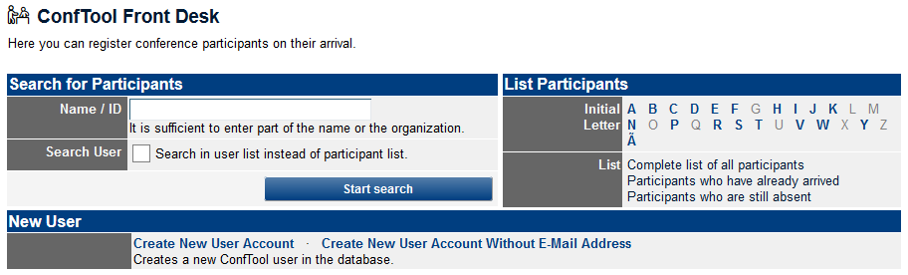

Search for Participant
To search for a participant, you can either enter the name, a part of the name or the User ID in the "Name/ID" input field on the left side, or filter the participant by the first letter of his/her last name on the right side. Usually the most efficient way is to enter the first 4-5 letters of the first or last name in the text field (Name/ID) and then to select the participant in the results list.

Check Receipt of Payment
In the participant's row, the column “Paid” (depending on the configuration) shows either a green payment amount (alternatively “Yes”), or in red “0.00” or another amount (alternatively “Unpaid”).

If the amount is green or “Yes”, everything is fine and you are ready to check-in the person (see “Check-in” below).

If the amount is red or “Unpaid”, please send the person to the Payment Desk on site. If someone comes to you who has already been at the Payment Desk because of an outstanding payment, please ask him/her to show you the signed form. Then just check-in the person as usual, see “Check-in” below.

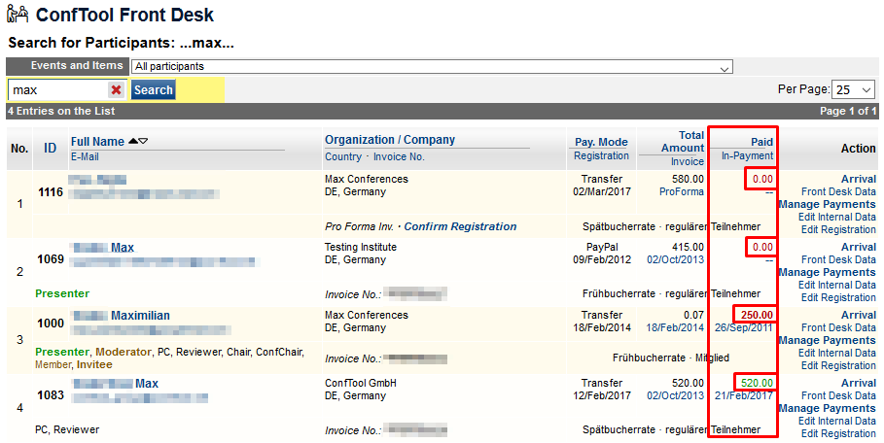

If a person has already been marked as “Has Arrived”, please search for the corresponding badge.
If a badge is available, someone has accidentally clicked on the wrong name and marked the person as having arrived. Then simply hand out the existing badge, see “Check-in” below.
If the badge is not available, please ask the person if he/she did already check-in before. If not please send him/her to the Special Desk.

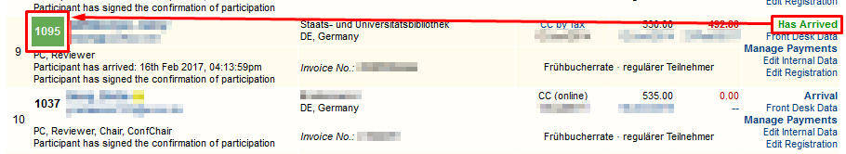

Check-in
Now click on “Arrival” and hand out the documents to the person as previously discussed (badge, bag, etc.).

If you clicked in the wrong row by mistake, just click again on “Has Arrived”. This will undo the check-in for the accidentally selected person.

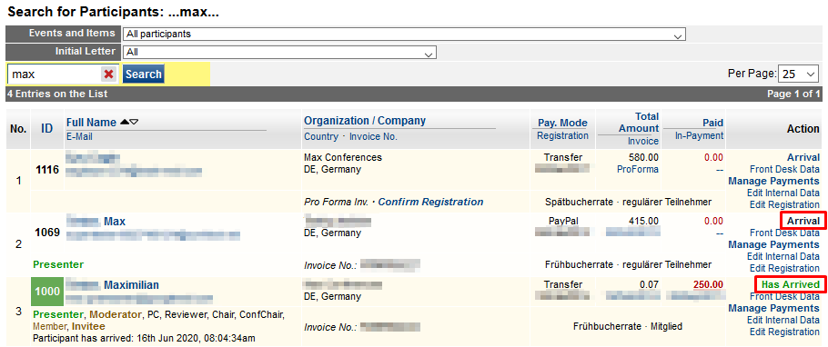

Participant not Found
It is possible that someone is registered as a user in the system, but not yet as a participant. Then you will not find him/her in this list. In this case, please activate the checkbox at “Search User” and search for the person again.

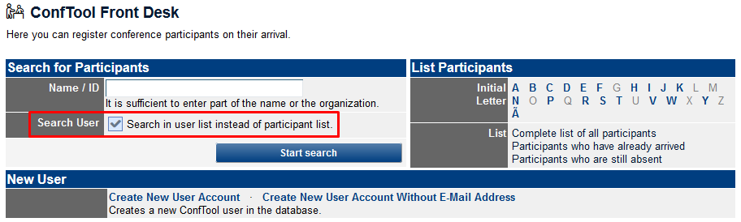

If the column “User Status/Role” does not contain “Partic.” for participant, please send the person to the Special Desk on site, noting that he/she has only been registered as a user/author etc. and not yet as a participant.

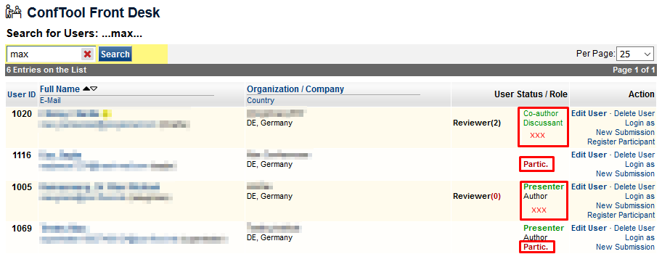

If you cannot find the person in the system at all, please ask the person to verify your spelling.
If you still cannot find the person, please send him/her to the local Special Desk with the information that he/she has not yet been registered in the system.

Participant Found, but no Badge Available
If everything else is all right, the participant has probably registered after the export for the badges was made (on date). Then please use the ConfTool function to print out a new badge, or if not available, fill out a blank badge with the name of the participant by hand.
Only if the person is already marked as “Has Arrived”, please send him/her to the Special Desk.

Someone is Complaining about Something
Please always stay calm and friendly. Remember that most participants had probably a stressful journey. Please send the person on site to the Special Desk for further assistance.

